**One factor model on Brent oil**

Group member: A0197899R HAO ZHENG; A0133805L YUE CHEN; A0056220W SHAOPU SONG; A0198016B XIANKUI AO

### Model and Data

We had conducted simulated trading on futures of crude oil and metal during the first half of the semester. Facing huge fluctuation on the net value caused by the volatility of those commodities price, we are very interested in the volatility and the way of how to price the option of those futures. So, we decide to research how to price and calibrate call option on Brent oil (CO1 commodity).

For the model, we choose one factor model in which we assume that the Brent oil Forward price follows a Geometric Brownian Motion (GBM) process with time-dependent volatility as following:

**Our model:**

parametrical vol function one factor model

where F(t, T) is the price of forward that expires at T, σ(t, T) is the volatility function and W is the standard Brownian motion. And for the volatility function, we choose parametric volatility function as follows:

Where we assume σ(t) to be of a function of a, b and γ, which are to be estimated with market data.

**Data：**

We get data from Bloomberg from 2018-01-02-2020-03-06, which contains call options prices, spot underlying prices(S), with strike at 50 and expiry date at 2020-03-26. Plots of option and spot prices are as following:

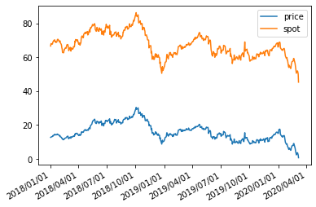

Fig 1.1 Historical option price and spot price of CO01 Commodity

### Implied Vol

**Newton-Raphson to solve the** **implied vol:**

we know the S,T,r,t and c, we want to find a sigma that match the observed price in the market. However, there is no close-form solution for the implied vol. Thus we use Newton-Raphson method to derive the implied vol we want, and iteral formula is as following:

Where

r is learning rate,

is the price observed from market.

However, for some time, the option will be deep in the money, so we can’t find a positive for the option because the Vega is nearly equal to zero at that time. Result of fitted vol is as following. As soon as we get the implied from the option price, under our single factor model, we should optimize the following term.

Using Non-linear least squares we can get our fit result as the following:

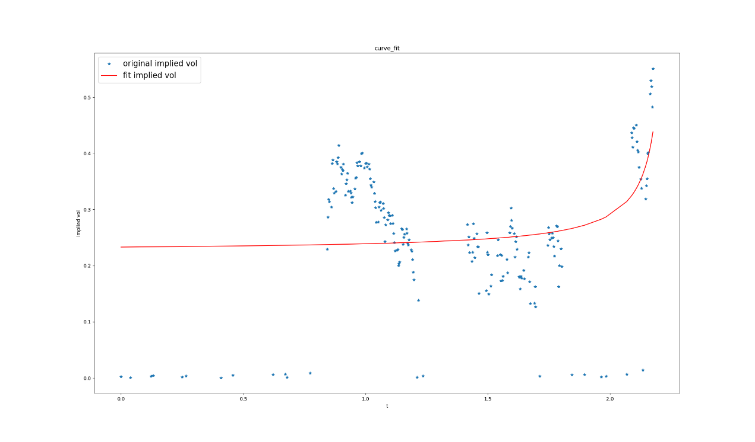

Fig 2.1 implied vol and fit vol(BS formula)

**Realized vol:**

The second approach is to use future price’s realized vol in the recent 10 periods as an estimate**.** This method however provides less theoretical support (and we may enhance it with GARCH or EWMA). With implied vol obtained, we should calibrate our vol function with the implied vol we get. We also use the formula above for our optimization

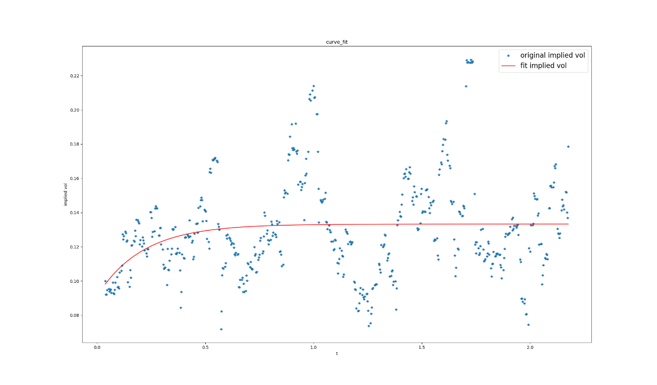

Fig 2.2 implied vol and fit vol(Future’s realized vol)

### Price Back:

As soon as we have the fit vol, options prices can be obtained with input such as: strike, spot price, vol and time to maturity. Two methods are used to price the options: the first is a close form of B-S formula while second is Monte Carlo simulations. Result are as following, and we can see that the obtained prices closely follow the market prices with some minor discrepancies, which will be discussed in the next section.

**Realized vol:**

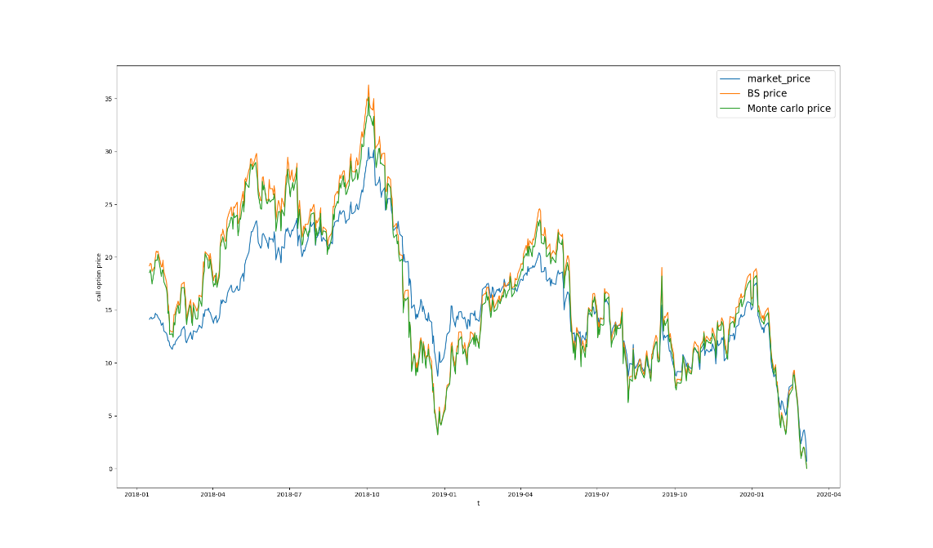

Fig 3.1 Market price against BS price against Monte Carlo price

**Implied vol:**

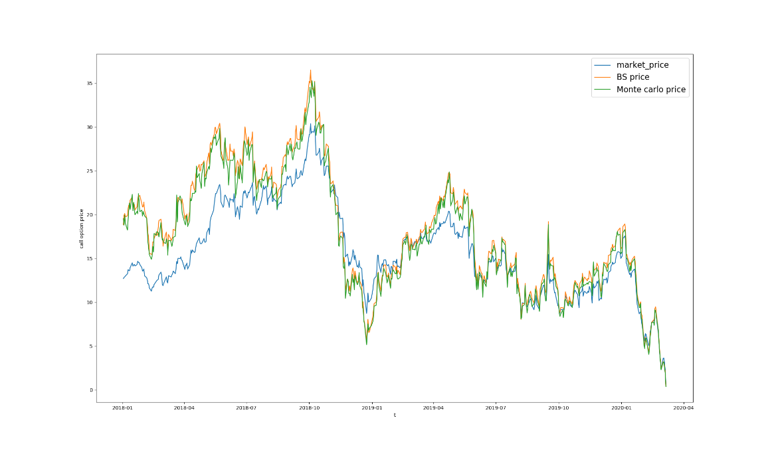

Fig 3.2 Market price against BS price against Monte Carlo price

### Result and Analysis

The Mean Squared Error (MSE), Mean Absolute Deviation (MAD) and Mean Absolute Percentage

Error (MAPE) of the results are tabulated below. Clearly, the winner is “Realized Vol - Simulate Price” in terms of all three measures. Also, in generally, the Monte Carlo Simulations approaches produced better results than Theoretical Prices and Realized Vol methods are more precise than Implied Vol approach.



Also as shown below, for both apporaches, the fitted prices will be higher than market during 2018-01-01 to 2018-10-01 period and very consistent with market price from 2018-10-01 onwards. This could possibly be explained by low implied vol in the market before 2018-10-01 as the option is deep Out of Money (OTM), and market players were not expecting much value from such options. Such options prices may be stale or deviant from its intrinsic values as there may be only small number of buyer/seller interest.



Fig 4.1 Error of realized vol method



Fig 4.2 Error of BS implied vol method